|  |  |  |
| --- | --- | --- |
| **LAB xxx Assignment** | **Type:** | **Long Assignment** |
| **Code:** | **J3.L.P0044** |
| **LOC:** | **300** |
| **Slot(s):** | **10** |

**Title:** Subject management

**Background**

**Program Specifications**

Program a web site to Add and View Subject

**Features:**

This website contains 2 main functions

* Function 1 : Default page : ( see PIC 01)
  + Default display all subject (see PIC 01)
  + Can search subject by department (see Pic 02)
  + Can filter subject by subject code or subject name (see Pic 03)
  + Button add new subject (see PIC 01)

Redirect to Page add new subject when click button **Add new**

* Function 2 : Add Subject (see PIC 04)
  + Data input
    - Campus: can fix one value
    - Chose Department from list
    - Input subject code
    - Input subject name by Vietnamese
    - Input subject name by English
    - Input subject short name
    - Input grade: etc.: 10, 11, 12 …
    - Input term: etc.: 1,2
    - Check Is extra subject or not
  + Save and validate data
    - Validate data
      * Department must be available in database
      * Subject code must be unique in subject table, if Subject code available in database show alert or message “Subject code is existing please input Subject code again”
      * Subject name by Vietnamese and English must be not null
      * Short name must be not null
      * Grade must be number > 0
      * Term must be number > 0
    - Save data
      * When Save successfully show alert or message to user and then redirect to **Subject list** page
      * If error occur, show alert or message to user

You do not need to write interface for admin control panel, you can add data manually (use SQL SERVER Management studio).

Note: All data must be load from database, not hard code in page.

**Slot:** should be store in database with fields: slot no, start time, end time.

***Expectation of User interface:***

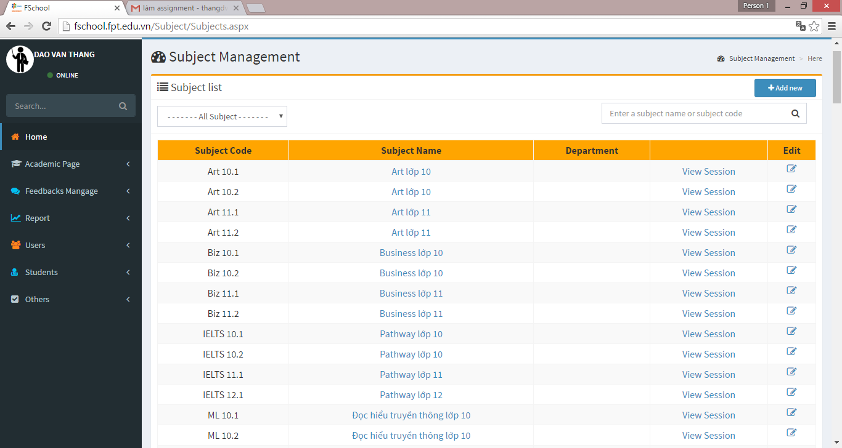

**Add new button**

Pic 01: Home Page ( TOP)

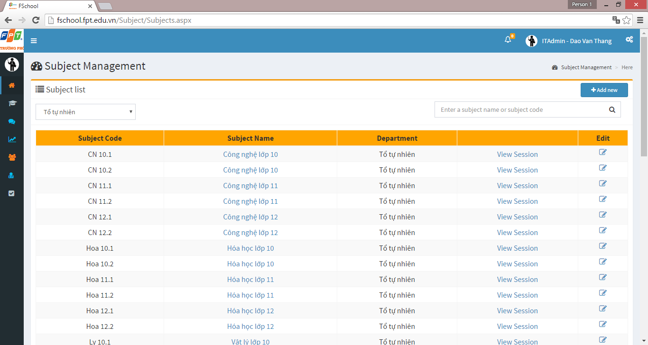

**Department list**

PIC 2: Search by department

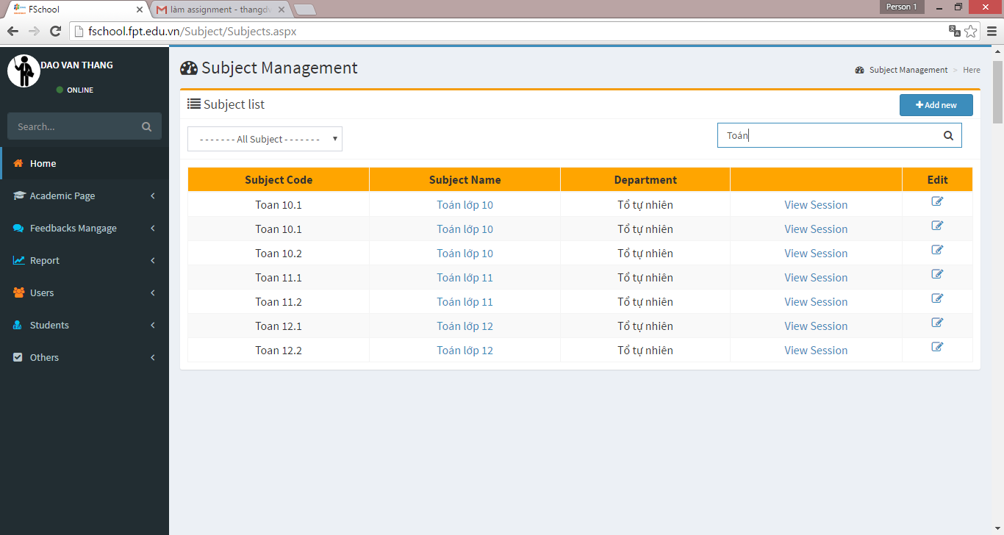

**Filter box**

PIC 3: Filter subject by subject code or subject name

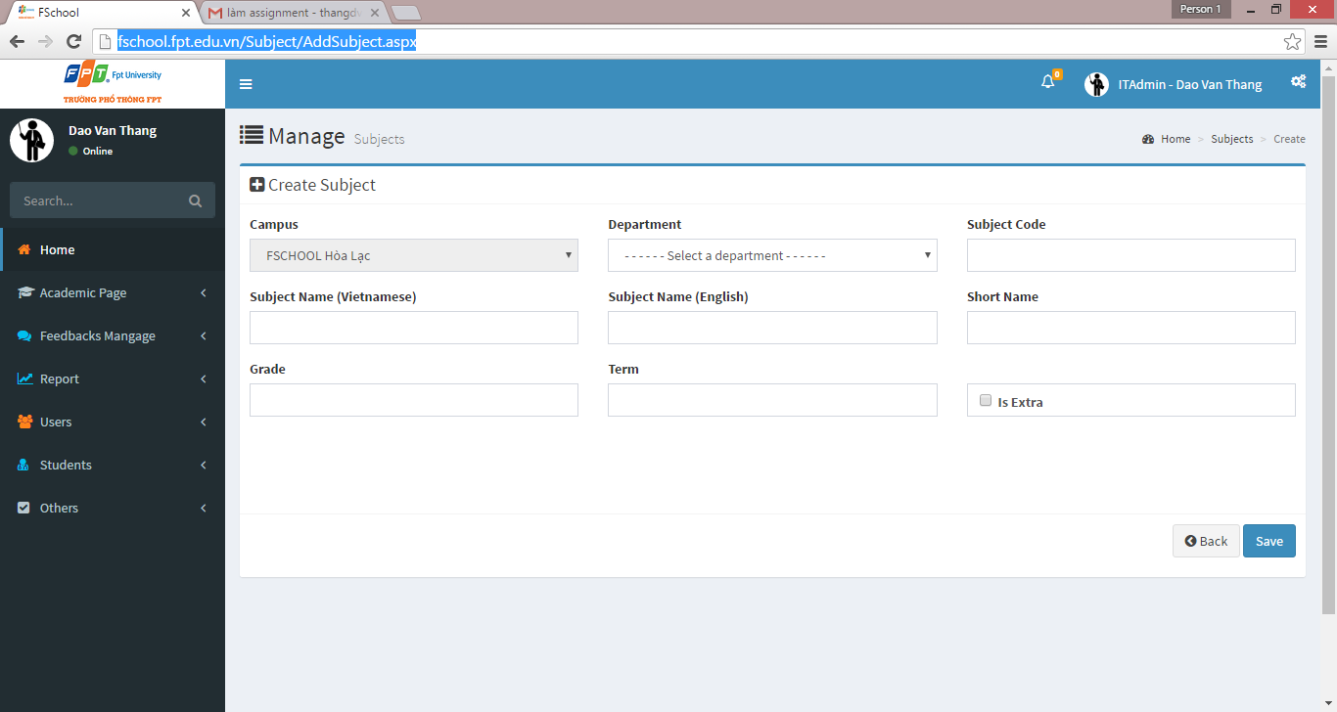

PIC 4: Add new subject

**Guidelines**

* Step 1 : Create web layout
* Step 2 : Create prototype
* Step 3 : Design database base on created prototype
* Step 4 : Code & Test